Aver BD-NEXR6004M - 4ch Pure IP NVR w/ GUI & local display

Part Number: BD-NEXR6004M

• 4 Channel NVR
• Embedded Linux
• Award-Winning GUI
• Support 2.3MP/channel
• Dual LAN Ports
• Comprehensive Remote Management
Don’t let the size fool you. The combination of efficiency, power and affordability with high quality MegaPixel video images, makes the mini twice as powerful in half the size! Designed to manage four IP cameras, the EXR6004 Mini is the NVR for everyone looking for spectacular image quality, better bandwidth and robust local/remote support at a fraction of the price of comparable NVRs.
MegaPixel Picture Quality – Really Do We Need to Say More?
2.3 MegaPixel per channel support makes video surveillance footage actually effective. View live video in crystal clear detail. Zoom in without pixilation on suspicious areas. And connect to over 50 brands of IP cameras.
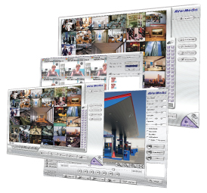 | Usability - Built into Product Design  A Linux OS to add stability. A user endorsed Graphical User Interface that makes managing video much simpler. A compact and lightweight profile that tucks easily under check-out counters, in back offices and in small bedroom closets. And finally an eSATA interface that makes sure you have plenty of storage.
Mobility - It Really Does Go the Distance  iPhone, Blackberry, Windows Mobile, remote computers and laptops. You got an internet connection - You got video. One of the biggest advantages of the Mini is that it records and replays simultaneously and can be remotely viewed by a number of independent authorized users. | 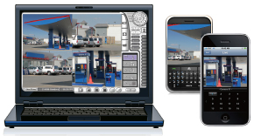
Connectivity - Unlimits Bandwidth
The Mini is equipped with Dual LAN Ports that allow you to create two separate networks, one for cameras and one for traffic from remote access, helping alleviate bandwidth limitations. And to further reduce network traffic, the Mini offers a local monitor connection so you can view and control your NVR locally as well as remotely.

